DDL Commands – CREATE, ALTER, DROP

AIM: To Create, Alter, Drop, Rename, Truncate using Data Definition Language (DDL) statements.

Description:
Data Definition Language (DDL) statements are used to define the database structure or schema.
DDL Commands: Create, Alter, Drop, Rename, Truncate
➢ CREATE - to create objects in the database
➢ ALTER - alters the structure of the database
➢DROP - delete objects from the database
➢ TRUNCATE - remove all records from a table, including all spaces allocated for the records are removed
➢ RENAME - rename an object

SYNTAX:

CREATE TABLE
CREATE TABLE table_name
(
column_name1 data_type,
column_name2 data_type,

column_name3 data_type,
...
);

ALTER A TABLE
To add a column in a table
ALTER TABLE table_name
ADD column_namedatatype;

To delete a column in a table
ALTER TABLE table_name
DROP COLUMN column_name;

DROP TABLE
DROP TABLE table_name;

TRUNCATE TABLE
TRUNCATE TABLE table_name;

Questions:
- Create a table name STUDENT with following structure.
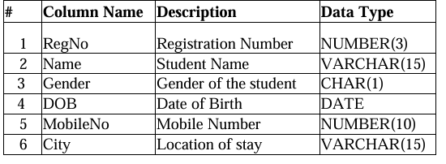

- Create a table name FACULTY with following structure.
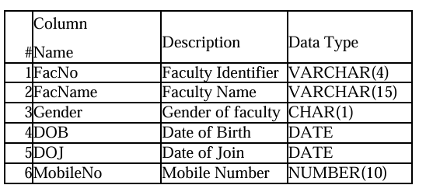

- Create a table name DEPARTMENT with following structure.

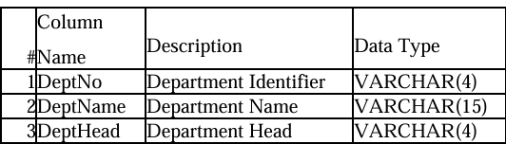

- Create a table name COURSE with following structure.

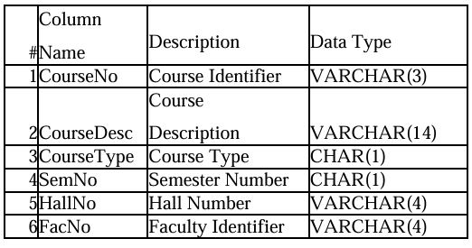

5) Modify the table FACULTY by adding a column name Dept of datatype VARCHAR(10)

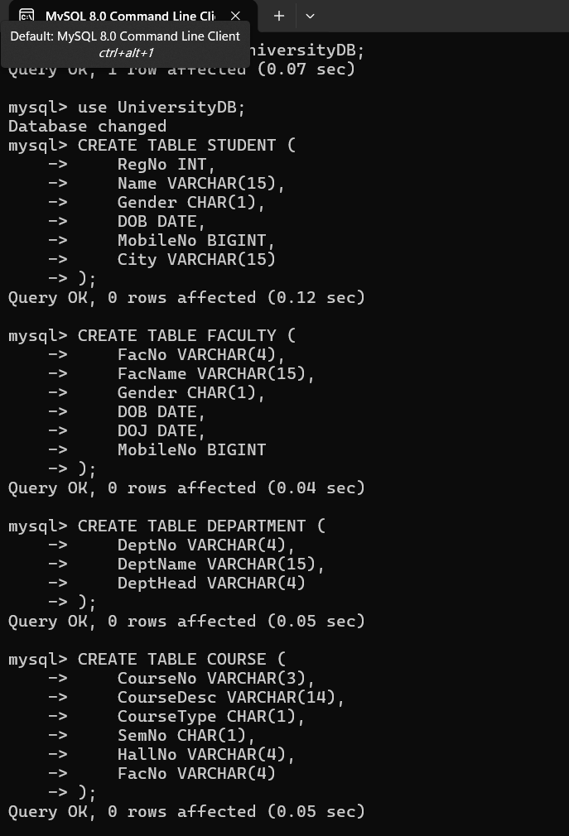
OUTPUTS:

